Adding folder

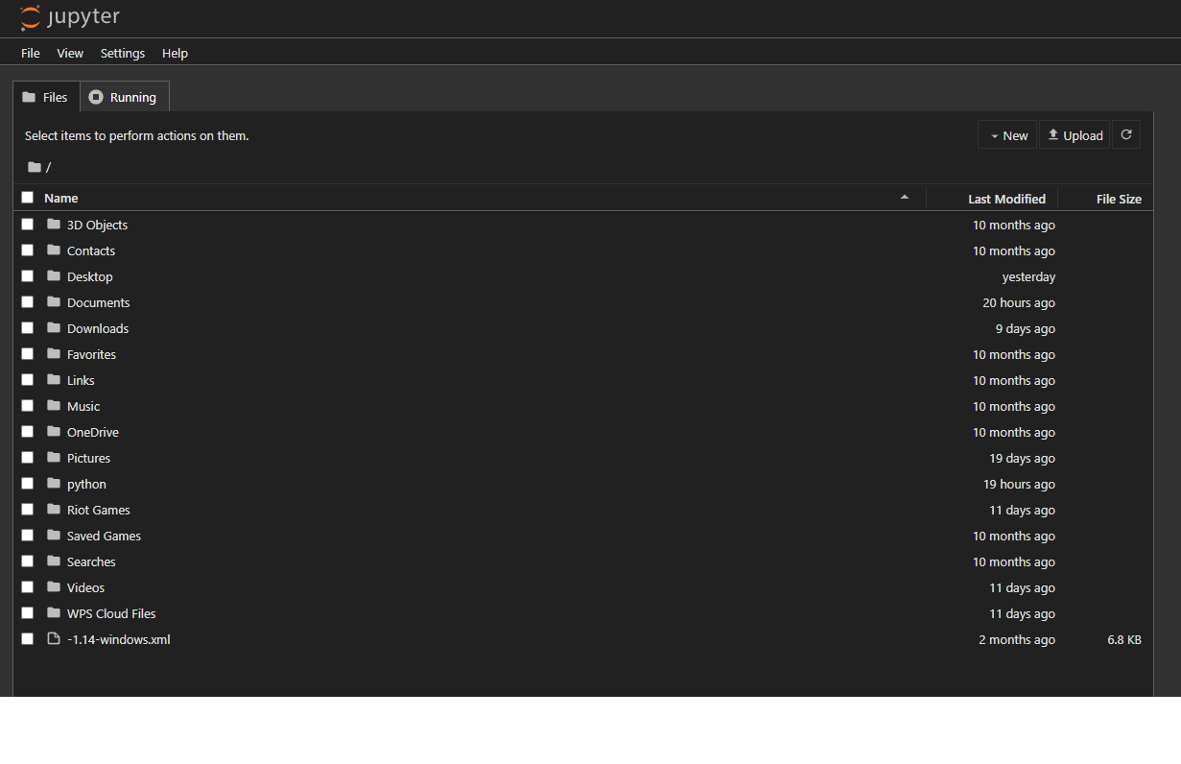

Adding text file

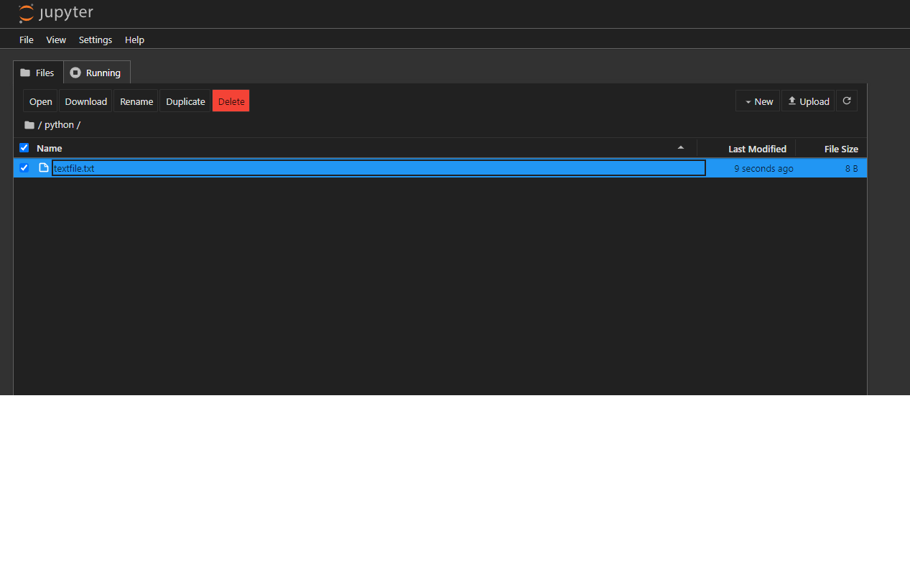

CSV file for data analysis and visualization

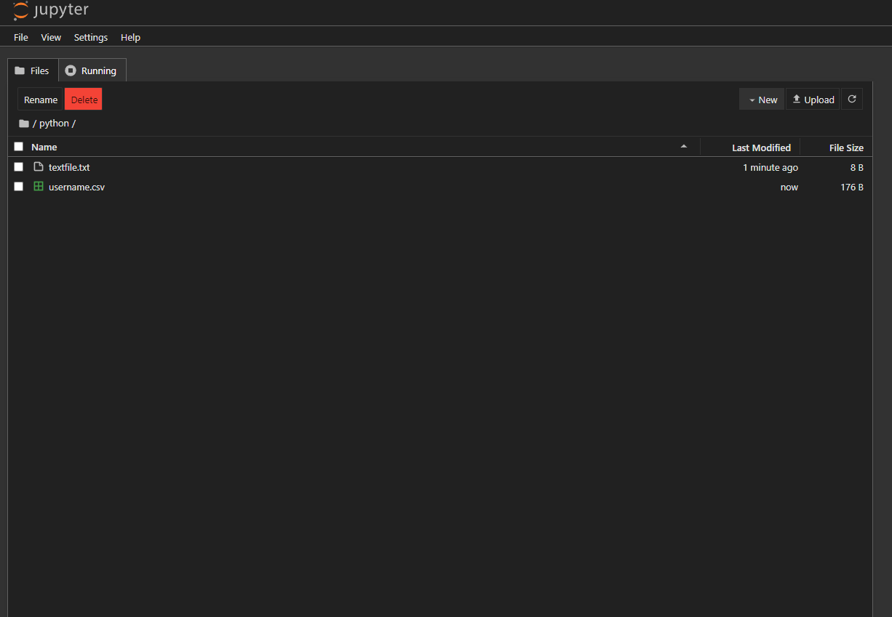

To write and call dictionary methods.

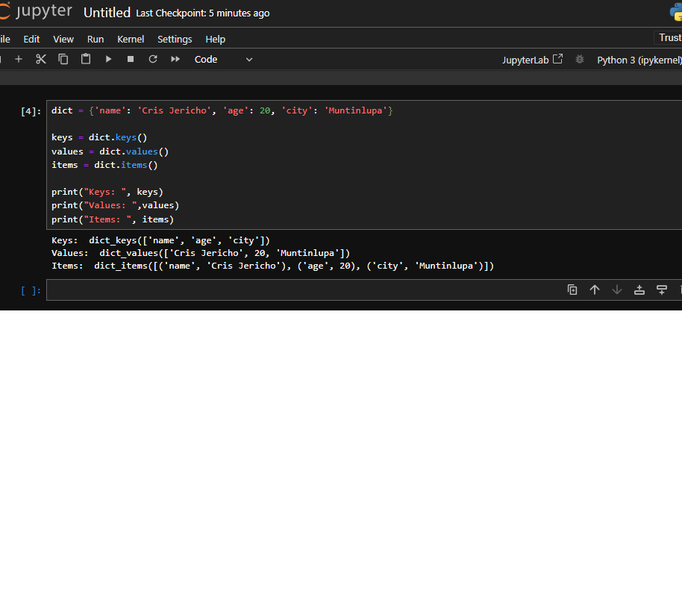

To create a directory using jupyter notebook.

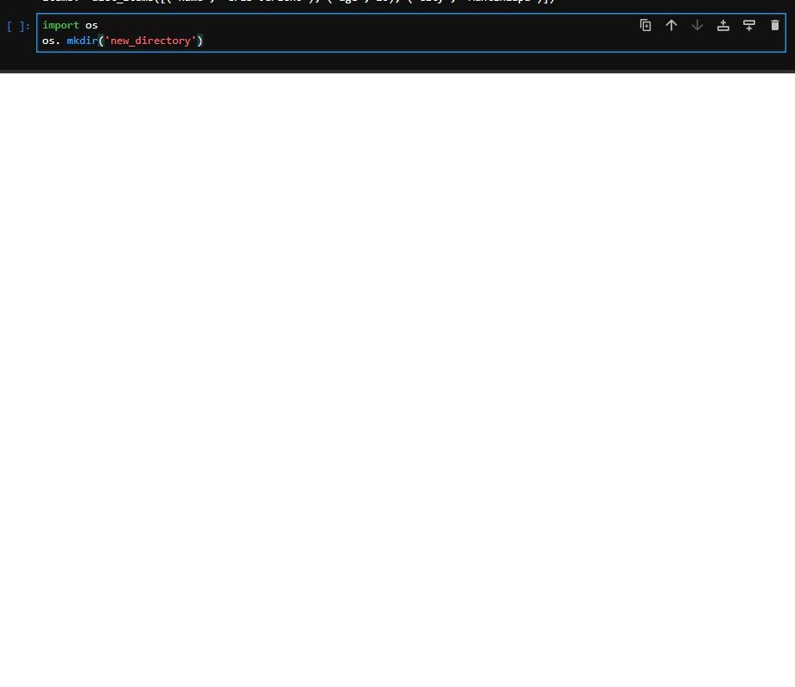

* To use CSV file for data analysis and visualization
* Import libraries
* Finding data
* Importing data
* Data attributes

